GCN Model Architecture

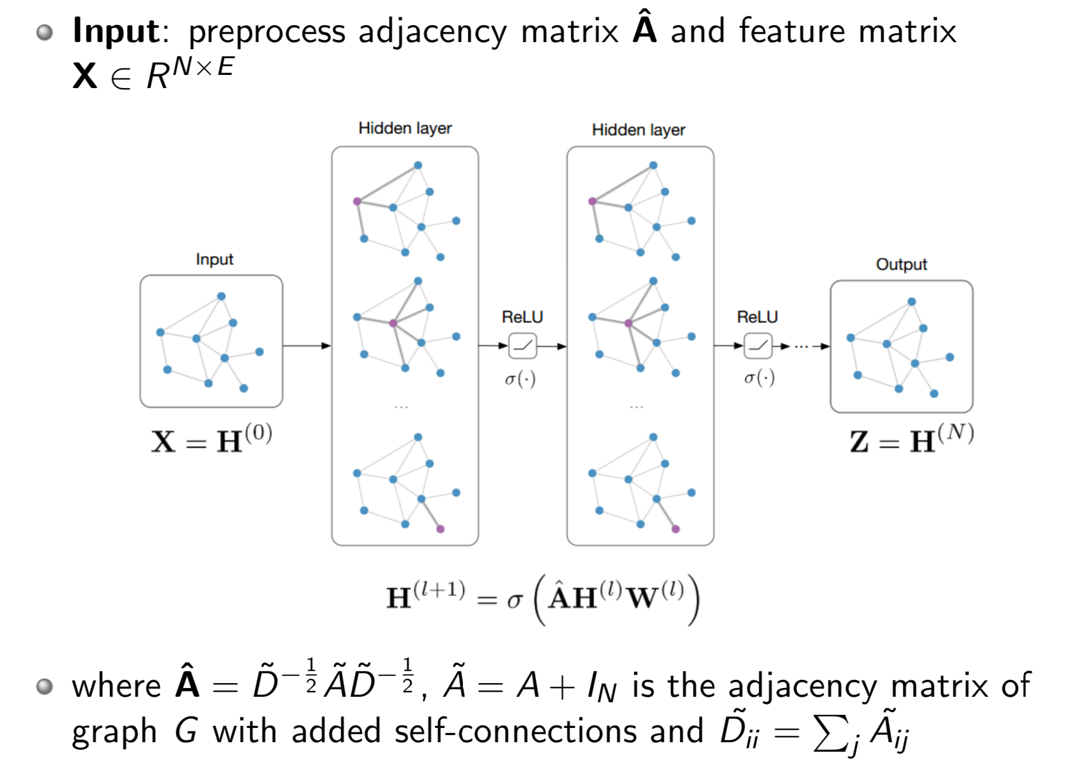

D^-1/2是节点的度矩阵开方分之一，邻接矩阵两边乘度矩阵是为了归一化，防止梯度消失或爆炸



同时聚合v的邻居和它自身



**GraphSAGE Model Arthitecture**

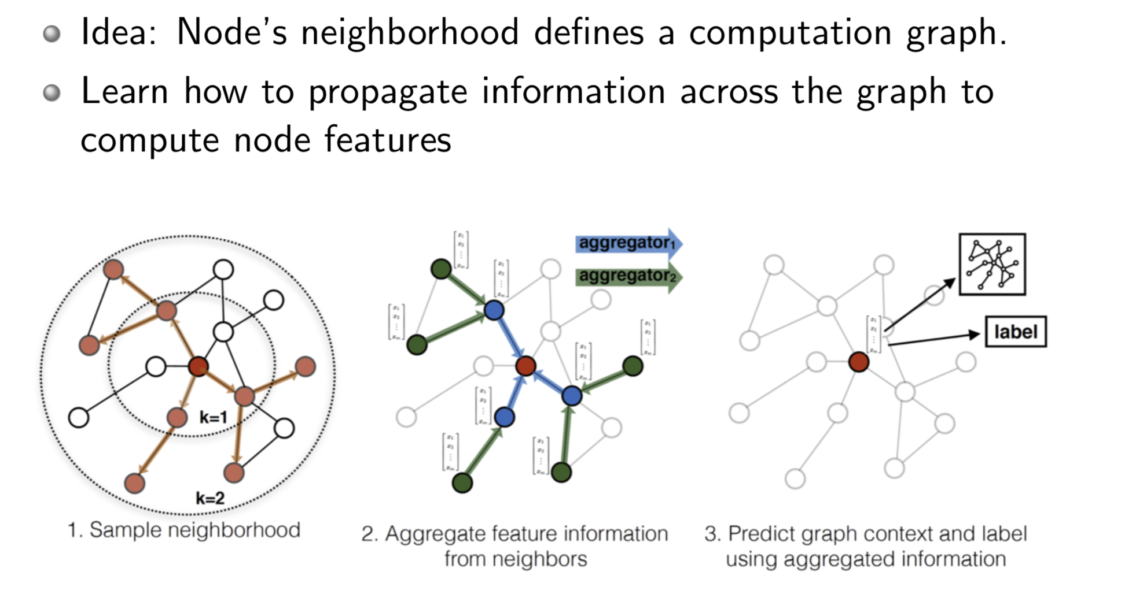



Instead of summation, it concatenate neighbor & self embeddings

**Graph Attention Networks**



